2024003 Botany Downs College

Flashings

w

**Watertight**

**ROOFING**

Flashings - Checklist: no activity

First Activity: No Activity Passed: 0

Last Activity: No Activity Failed: 0

N/A: 0

## Drip edge flashings



Correct girth as per plan verlaps are sealed and riveted

Free from damages and scratches



## Barge flashings

Correct girth as per plan Overlaps are sealed and riveted

-

*/*

frJ>m damages and scratches



## Head flasti'l,Qgs

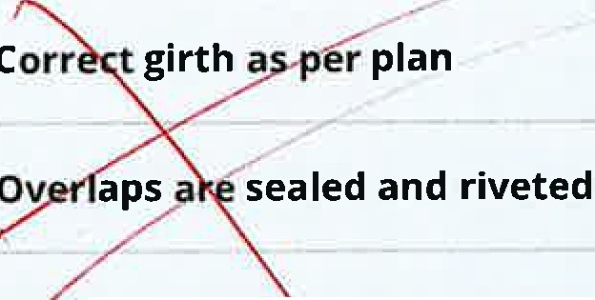*ie*from damaxes and scratches

'

## Apron flashings

\nO\J· l

prnovt-- 1



## Parape9c s

Corre.,ct girth--as per plan *\)t-*

Flashings - Flashings 2024003 Botany Downs College

*\[fl*



·vetett-

# /Penetration flashings

Correct girth as per plan Overlaps are sealed and riveted

Free from damages and scratches

J&J *r*

lu\jP'

*·,v>Sl•ct-ltacl--*T*\* .

# /Parapets

Correct size flashings

Under soakers installed as per details Fixings at 300 0



Expansion joints installed

Caps completed and damage free

# vA'eads + Barges

Correct size flashings



Under fixings in places+ correct fixings Expansion joints installed

Fibretite flashing install membrane & welded to flashing correctly

